REMOVE FOOD ITEM TESTS

- Remove food item from diary
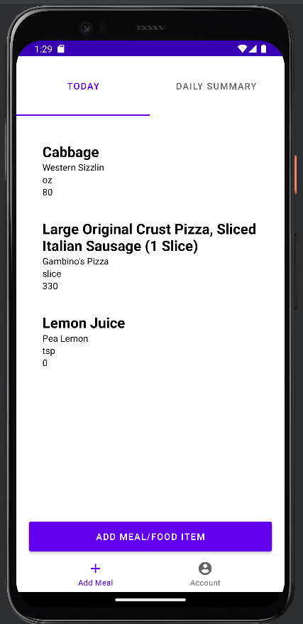

(Long hold on item)

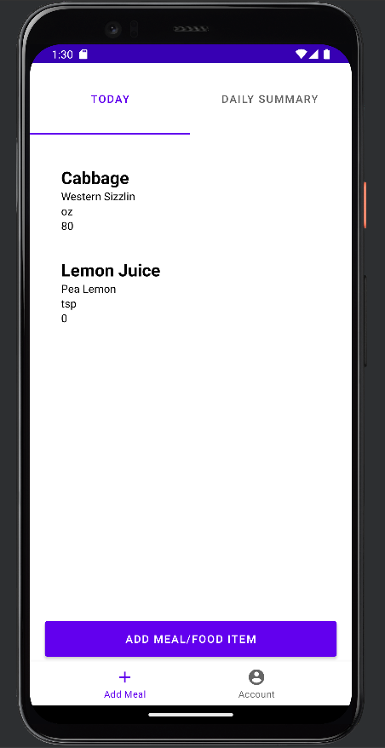

ITEM REMOVED TEST PASSED

- Remove item kill application and return to ensure removal is stored
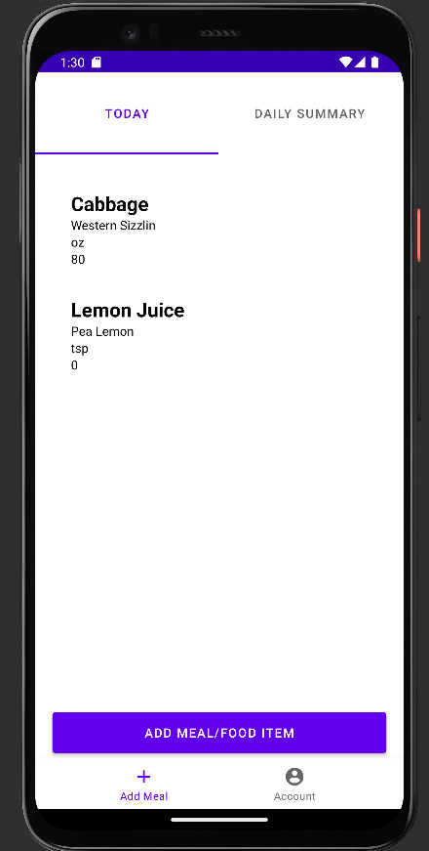

Long hold on item to remove

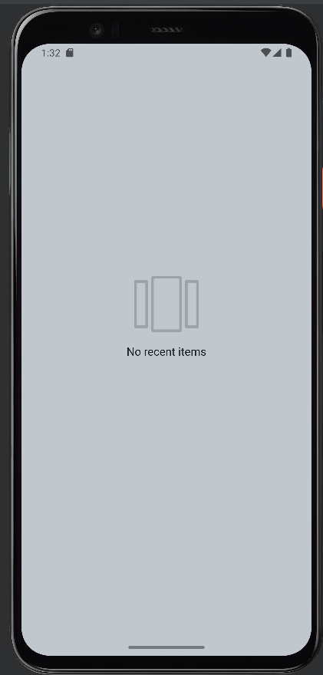

Application killed

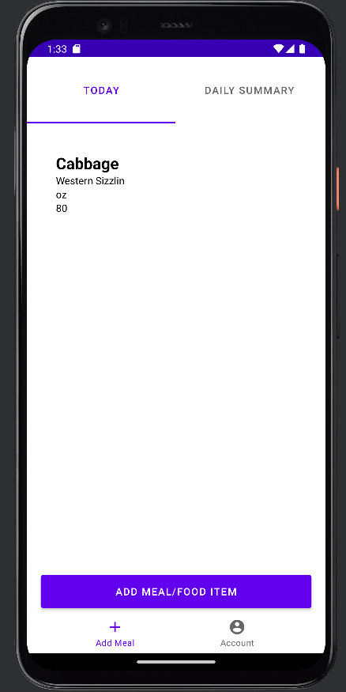

Removal was saved TEST PASSED

